**HOW TO MAKE A RESERVATION WITH A GROUP PREFERENTIAL CODE**

1. Go to [www.sofitel.com](http://www.sofitel.com) website



1. Type “Sofitel London Heathrow” in the destination box, select the dates you wish to book



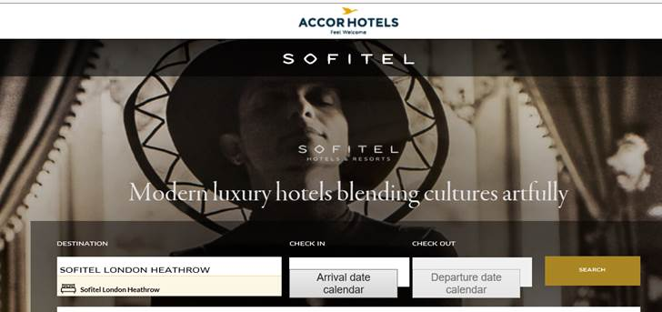

1. Type in the preferential code provided (EVEBB)

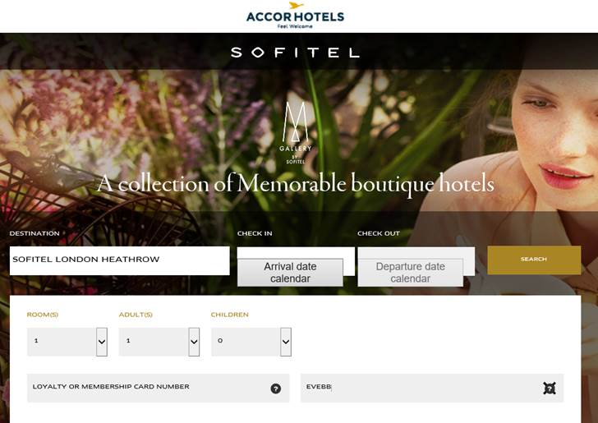

You will see selection of room types available at the hotel. Room type with a gift icon is the one you need to select as the icon indicates preferential rates for your event

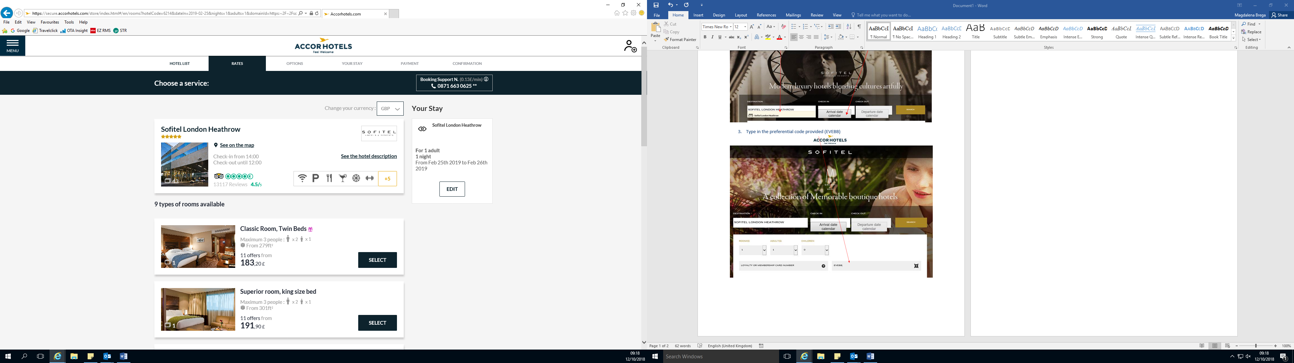

1. You can select the preferential rate after selecting the room type with a gift icon

